**Skype for Business and Polycom Handset Process to use New Skype Domain**

|  |  |  |
| --- | --- | --- |
| *Version* | *Written/Reviewed By* | *Date* |
| 0.1 | Ronan Dunphy | 21st May 2019 |
| 0.2 | Tony Crofts | 3rd July 2019 |
| 0.3 | Patricia Gray | 24th July 2019 |

Contents

Overview 3

Skype for Business and Polycom Handset Sign Out Process 3

Skype for Business and Polycom Handset Sign In Process 5

# Overview

The following document outlines the steps required to prepare a Polycom VVX411 phone for signing in to a new Skype domain. This document assumes Skype for Business 2016 client is installed on a PC or laptop, connected to a Polycom VVX411 phone and signing in connected to the same computer. This process applies to Microsoft Windows computers only.

# Skype for Business and Polycom Handset Sign Out Process

Sign-out of your Polycom phone may be required. If you are not signed out, please follow the steps below.

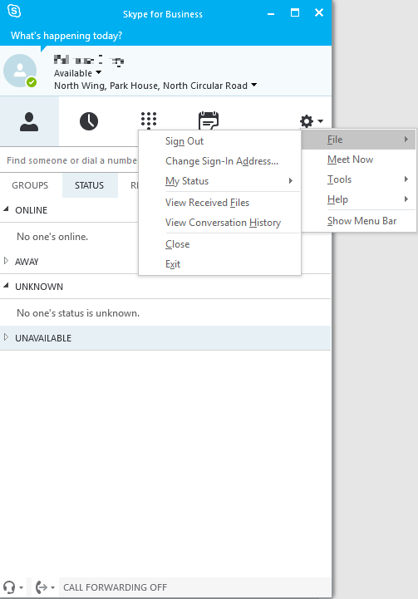

Step 1: Sign Out of Skype for Business

Click on the arrow down button to access the tab with “File”. Then click on “File” and finally click on “Sign Out”. This completes the sign out process on the Skype for Business application.

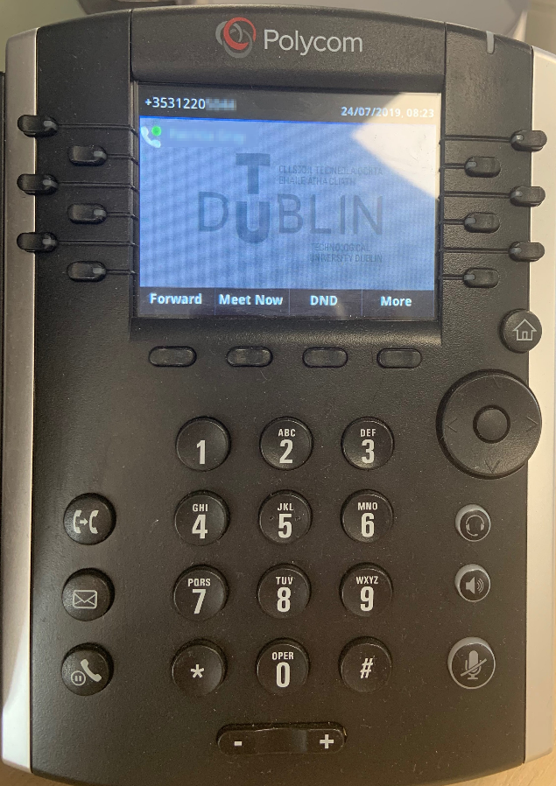

Step 2: Sign Out of Polycom Phone

Press the button below the “More” image.

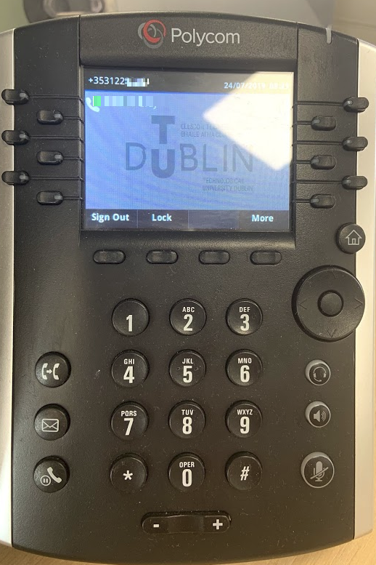

Step 3: Sign Out of Polycom Phone

Press the button below the “Sign Out” image. This  
completes the sign out process on the phone.

# Skype for Business and Polycom Handset Sign In Process

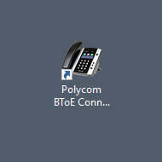

Step 1: Double click the Polycom BToE Connector desktop icon to confirm it is running.

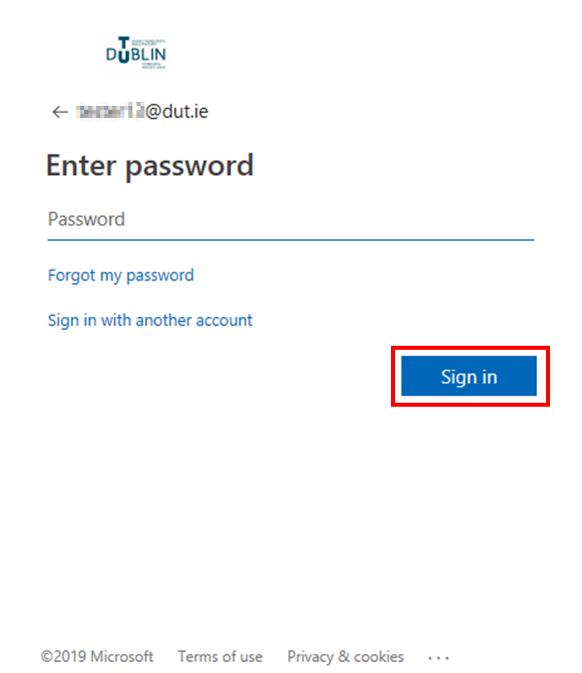

Step 3: Enter theassociated password in the “Password” box and press “Sign in”.

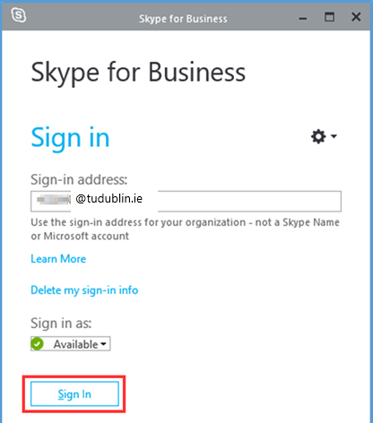Step 2: Open Skype for Business. Enter [*firstname.lastname@tudublin.ie*](mailto:firstname.lastname@tudublin.ie) in the Sign-in address box and then press “Sign-in”.

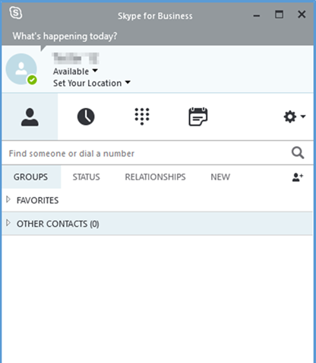

Step 4: You will be presented with this window once successfully logged in to Skype for Business.

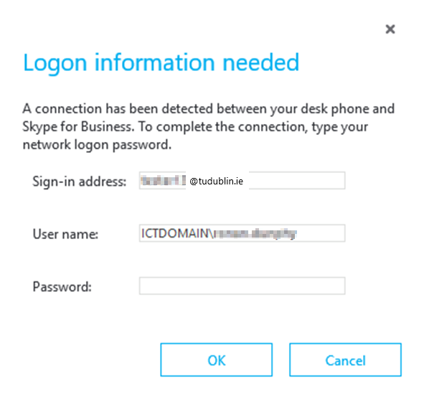Step 5: In the “*Logon information needed*” window enter [*firstname.lastname@tudublin.ie*](mailto:firstname.lastname@tudublin.ie) used in Step 2 in the “*Sign-in address*” and “*User name*” boxes. Note: If the “*User name*” box is prepopulated, delete this and enter [*firstname.lastname@tudublin.ie*](mailto:firstname.lastname@tudublin.ie)

c

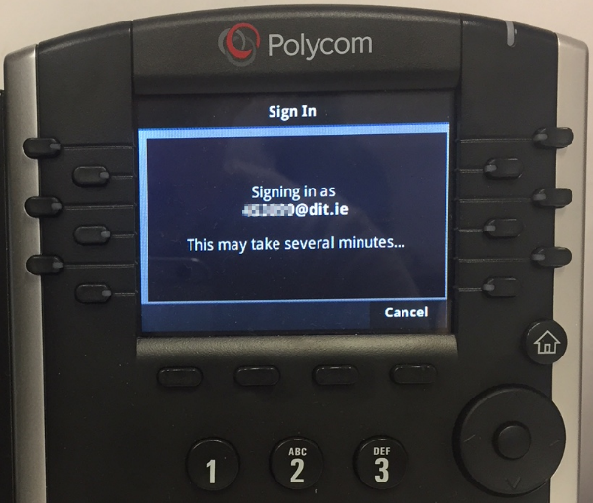

Step 7: The handset will begin the sign-in process. This may take several minutes.

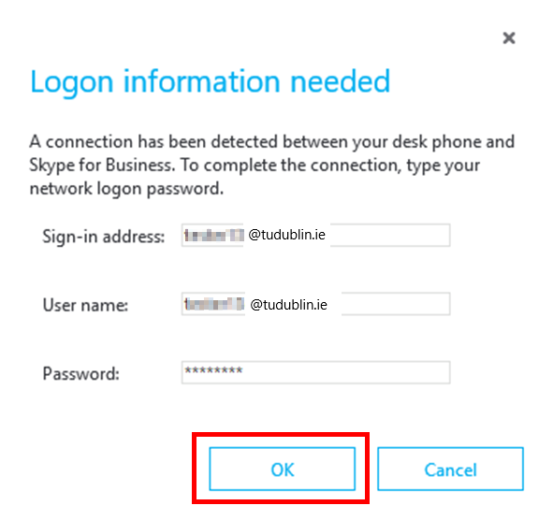

Step 6: Enter the password used in Step 3 into the “*Password*” box and press “OK”.

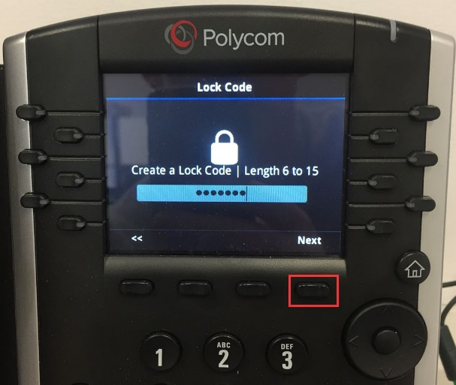

Step 8: When prompted enter a 6 to 15 digit lock code on the keypad and press the button below the “Next” image.

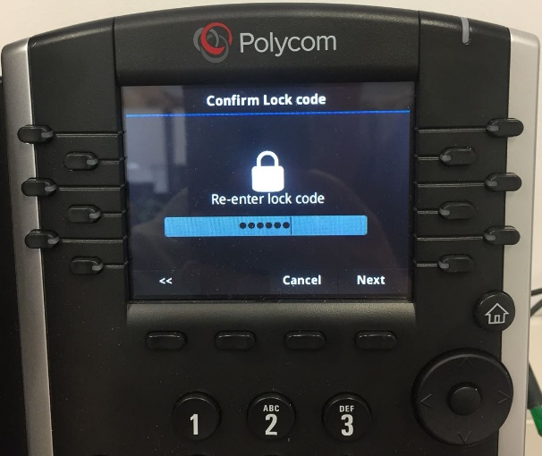

Step 9: Re-enter the lock code and press the button below the “Next” image.

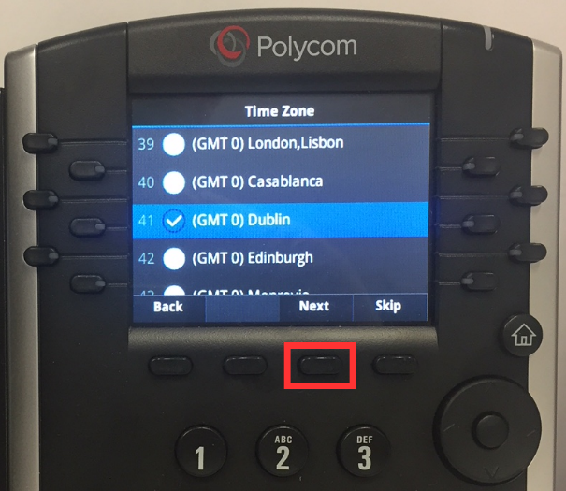

Step 11: Use the directional keypad to highlight the (GMT 0) Dublin timezone. Once highlighted press the button below the “Next” image.

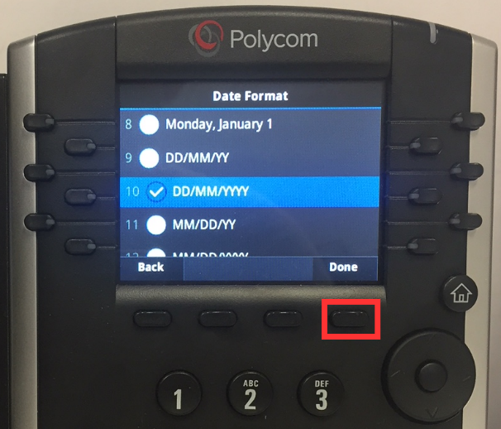

Step 13: Use the directional keypad to highlight the DD/MM/YYYY option. Once highlighted press the button below the “Done” image.

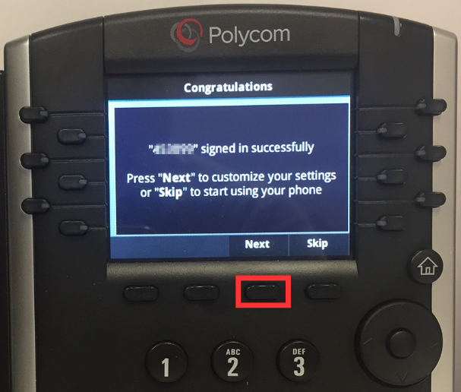

Step 10: Once signed in successfully, press the button below the “Next” image to continue the configuration process.

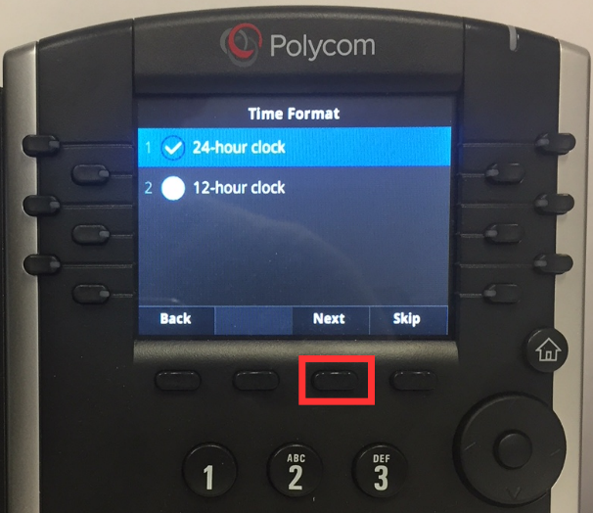Step 12: Use the directional keypad to highlight the 24-hour clock option. Once done press the button below the “Next” image.

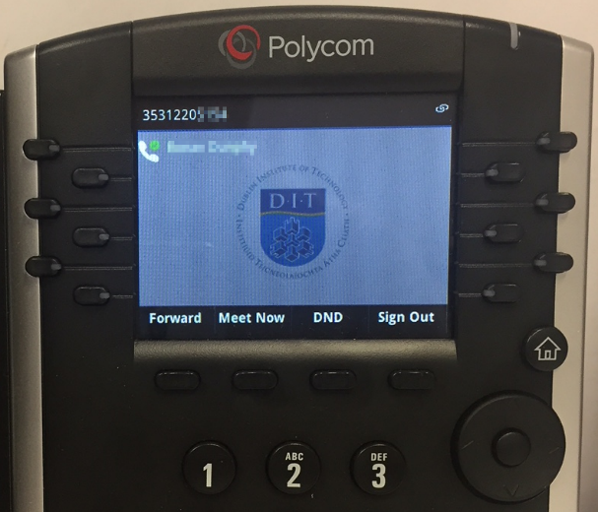Step 14: The sign in and pairing process are now complete. Your name should be listed on the handset and your new phone number will be visible in the top left hand corner.