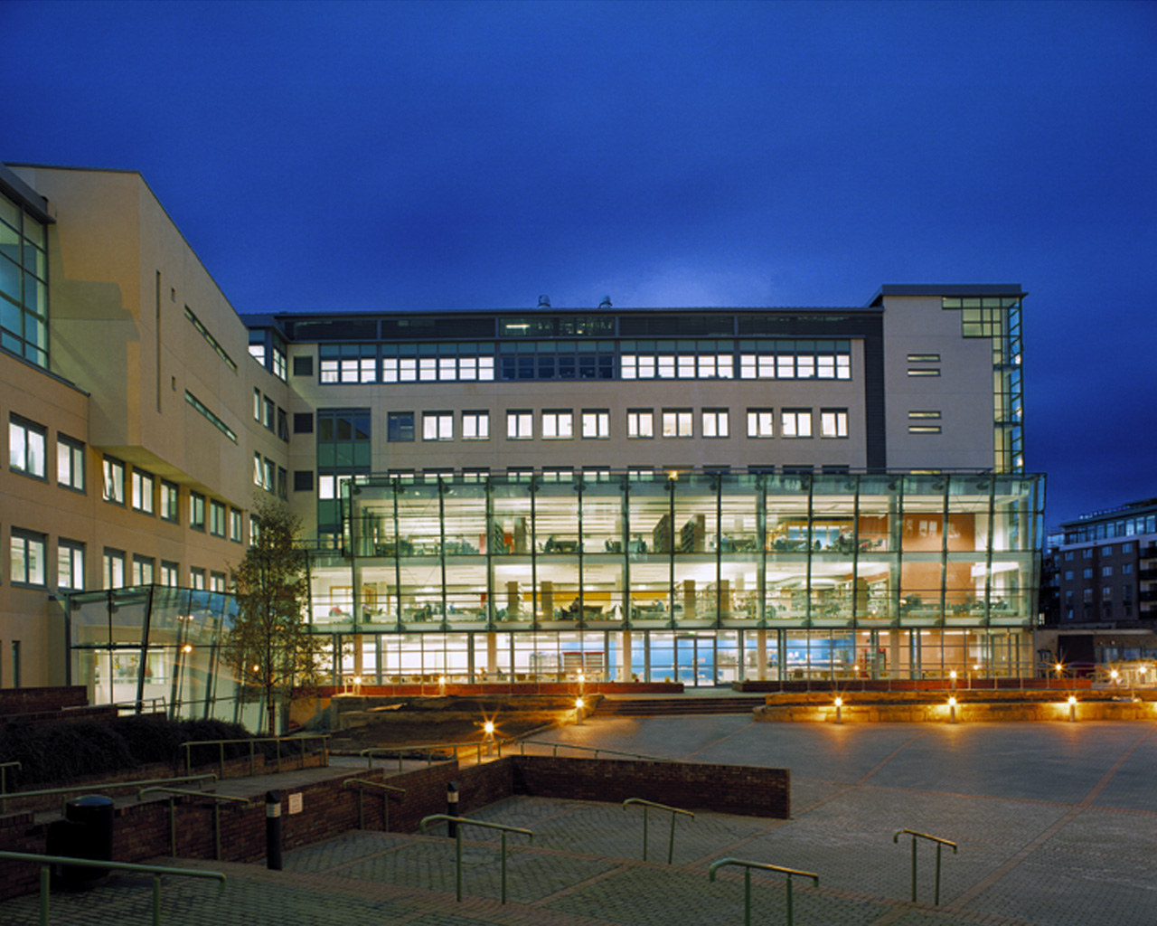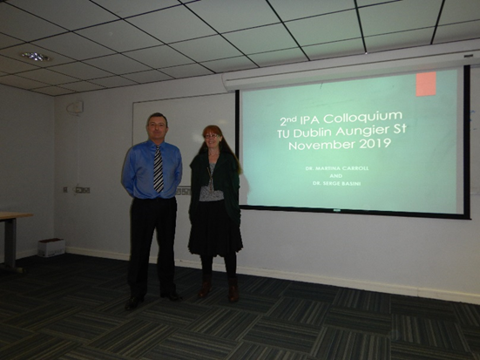



**Interpretative Phenomenological Analysis Colloquium Digest**

**2018 & 2019**

# **Introduction**

Welcome to the first of what we hope will be many editions of our IPA colloquium Digests. Through these annual colloquiums our aim has been to create a supportive and constructive atmosphere, where IPA researchers from Psychology, Business, Mental Health, Education, and other professional fields meet to present and discuss their IPA research.

Because all these fields have scientific foundations, such as Psychology and Medicine, it is important to ensure consistency within the scientific paradigm when using qualitative research methods. This means understanding the limitations and purpose of research with small samples i.e. a small number of participants. The findings of IPA research typically fall into a small number of categories. 1) Research that generates testable theory, where further research is necessary. 2) Research findings that point to an unexpected body of already existing research literature that has been overlooked or is within a different field. 3) Findings that generates a narrative that offers insights relevant for professional practitioners and of general interest.

We hope that this digest will help to promote a deeper understanding of the method leading to high quality research.

Serge Basini & Martina Carroll

**Consider Presenting?** If you would like to make a presentation about your IPA research, regardless of what stage you are at, please let us know. All are welcome to present. If you have completed your research and have been awarded your degree, we want you to share your experience and reflection of doing IPA research.

**Considering a Masters or a PhD?** We are interested in supervising multidisciplinary research with an IPA backdrop. Contact us Serge Basini, School of Marketing, TU Dublin, College of Business, City Campus, Aungier Street. [serge.basini@TUDublin.ie](mailto:serge.basini@TUDublin.ie) or Martina Carroll, [martina.carroll@ucd.ie](mailto:martina.carroll@ucd.ie)

See also:

* https://www.meetup.com/Interpretative-Phenomenological-Analysis-IPA-Ireland/events/255358230/
* twitter: IPA-research-IE :@ie_ipa
* ipaqualitative@groups.io

# **About IPA**

At the beginning we would like to introduce our readers to IPA. IPA stands for Interpretative Phenomenological Analysis, which is a psychological qualitative research method used for researching everyday lived experiences. Smith et al. (2009) discuss four major phenomenological philosophers' who contributed to IPA: Husserl, Heidegger, Merleau-Ponty, and Sartre. Husserl's work highlighted the significance of focusing on experience and the individual's personal interpretations of that experience. Heidegger, Merleau-Ponty and Sartre developed this further, emphasising that individuals exist in a 'lived world' rather than in isolation. As a result, an individual's participation in the lived world influences their perspective on their lives and experiences. This is an important aspect of IPA because researchers have come to appreciate their participants' complex sense-making processes, and it also relates to the ‘interpretative' aspect of IPA (Smith et al. 2009).

IPA has two more theoretical orientations, and is informed by the concepts and debates of the philosophy of knowledge which are: hermeneutics and idiography (Smith et al. 2009).

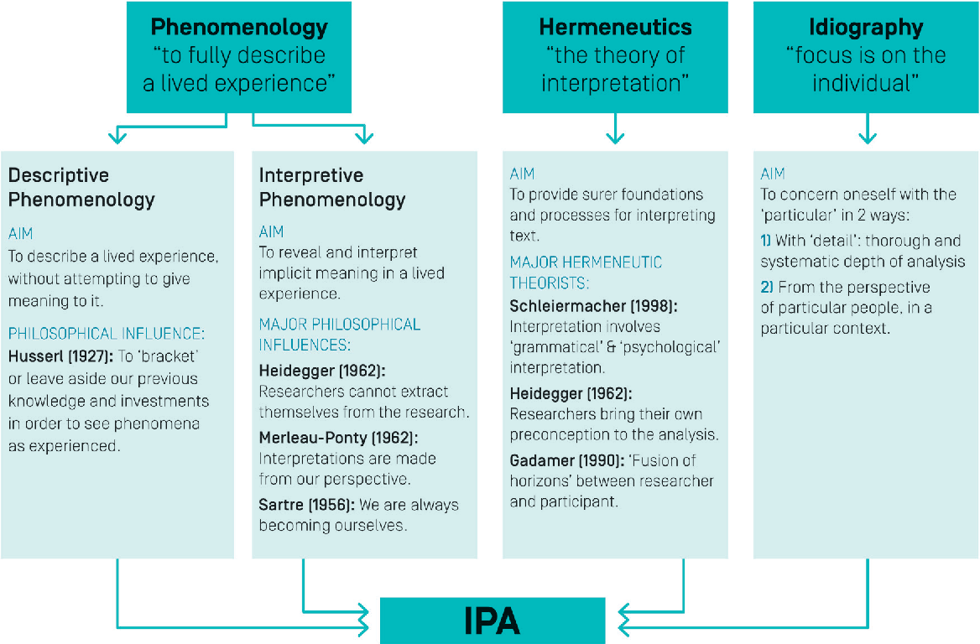

# **Sampling in IPA**

Samples are selected purposively (rather than through probability methods) because they can offer a research project insight into a particular experience (Smith et al., 2009). Participants are selected on the basis that they can grant access to a particular perspective on the phenomena under study. That is, they ‘represent’ a perspective, rather than a population. IPA studies are usually small, which enables a detailed and very time-consuming case-by-case analysis, and the researcher must decide whether he or she wants to give a comprehensive and in-depth analysis about a particular participant’s experiences or present a more general account on a group or specific population (Pietkiewicz & Smith, 2014). The aim of IPA is producing an in-depth examination of certain phenomena, and not generating a theory to be generalized over the whole population.

# **Data collection**

In IPA, there is an assumption that the data collected will tell us about peoples’ involvement in something of importance to them. From this stance, experiential change reflects and evolves out of a person’s shifting relationship with phenomena, bound up with their sense-making of what happens. It is therefore critical that data collection is facilitated by methods that encourage participants to provide a detailed account of their own feelings, concerns and thoughts as they arise and change over time (Farr & Nizza, 2019).

Semi-structured, in-depth, one-on-one interviews are the most popular method to achieve that, although other data gathering methods are also used, either alone or in combination with interviews, including focus groups, online postings and diaries. Semi-structured interviews allow the researcher and the participant to engage in a dialogue in real time. They also give enough space and ﬂexibility for original and unexpected issues to arise, which the researcher may investigate in more detail with further questions (Pietkiewicz & Smith, 2014).

# **Data analysis**

Analysing qualitative material using the IPA framework can be an inspiring activity, although complex and time consuming. It is recommended that researchers totally immerse themselves in the data or, in other words, try to step into the participants’ shoes as far as possible. IPA aims at giving evidence of the participants’ making sense of phenomena under investigation and, at the same time, document the researcher’s sense making (Pietkiewicz & Smith, 20014).

In general, IPA provides a set of ﬂexible guidelines which can be adapted by individual researchers according to their research objectives. However, these guidelines are merely an illustration of one possible way of analysing the qualitative material. They should not be treated as a recipe and the researcher is advised to be ﬂexible and creative in his or her thinking (Pietkiewicz & Smith, 2014).

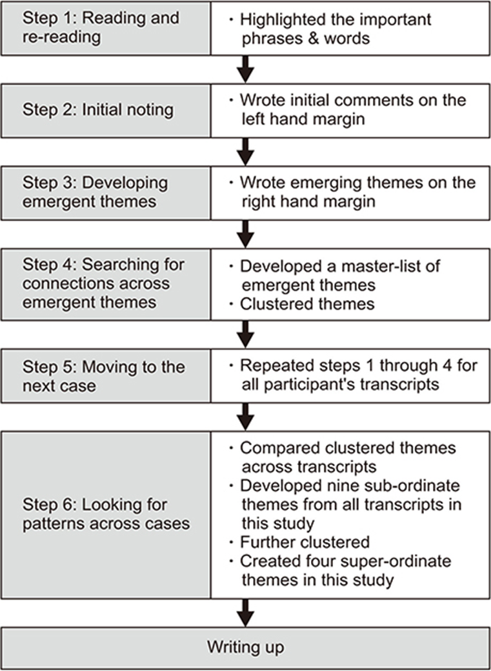

**Colloquia**

**1st Colloquium November 17th 2018**

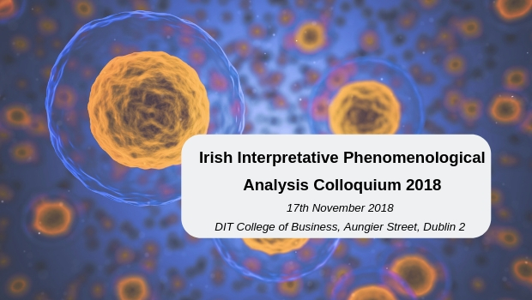

IPA Ireland hosted their inaugural Irish Interpretative Phenomenological Analysis (IPA) Colloquium at DIT College of Business, Aungier Street on Saturday 17th November 2018, co-chaired by Dr. Serge Basini (DIT) and Dr. Martina Carroll (UCD). A diverse range of national and international presenters from the fields of Medicine, Psychology, Psychotherapy, Organisational Science, Community Policy, International Development, Nursing and Educational Psychology gathered together to share their insights. This was a rare occasion for the community of IPA researchers to open up a conversation about IPA and an opportunity to map out the current state of IPA.

**1st Annual Colloquium, November 17th 2018**

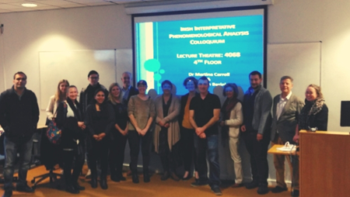

Opening Welcome & Colloquium Theme, Dr Serge Basini, Senior Lecturer, TU Dublin: *Paradigm Development in Organisational Science & IPA*. Opening Session 2, Dr Martina Carroll, Lecturer in Adult Education, University College Dublin.

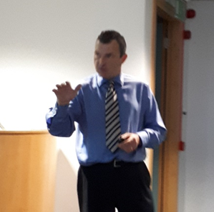

Panel 1 Chaired by Serge Basini

* **Abstract 1** Niamh Imbusch. *Defending the decision to use IPA to explore the experiences of mindful line managers*.
* **Abstract 2** Julie Longson. *Exploring childhood experiences of WW2 and its impact on mental health across the life course*.
* **Abstract 3** Dr. Leonard McCammon. *What IPA as my research approach did for me*.
* **Abstract 4** Joan Murphy. *The experience of hope in mental health recovery*.

Panel 2 Chaired by Martina Carroll

* **Abstract 5** Geri McLoughlin. *Managing data - moving from the descriptive to the Interpretative in IPA*.
* **Abstract 6** Dr. Martina Carroll. *Using IPA with Socially Engaged Arts*.
* **Abstract 7** Brian McGann. *Experiences of Autism*.
* **Abstract 8** Emma Mathias. *IPA as a methodology for understanding lived experiences of mental illness in Ghana*.

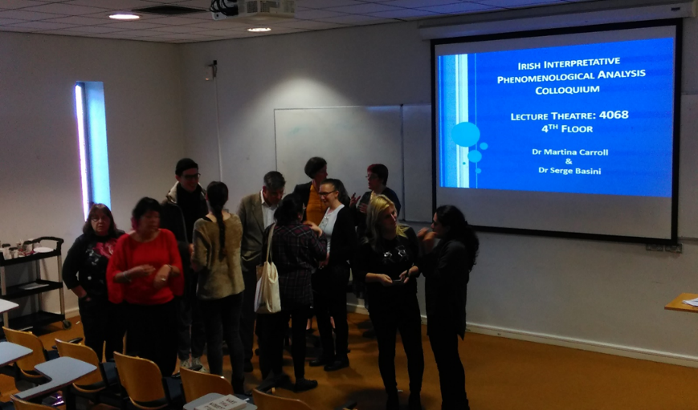

After hard work there is always a time for relaxing and informative discussion where all attendees can share their thoughts and learn from the others.

**_______________________________________________________________________________________2nd Annual Colloquium, November 9th 2019**

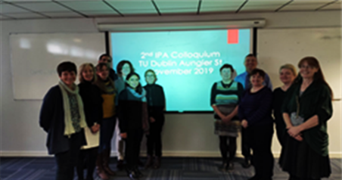

Opening Welcome: Dr Martina Carroll, Lecturer in Adult Education, University College Dublin. Keynote Address Colloquium Theme: Dr Serge Basini, Senior Lecturer, TU Dublin, Dialoguing with Quality in IPA studies

Panel 1 Chaired by Martina Carroll

* **Abstract 1** Joanna Kossykowska. *Getting Started: from Research Questions to finding Participants.*
* **Abstract 2** Mags Amond. *Make Mine a Double - the value of two-stage hermeneutic analysis to an insider - researcher.*
* **Abstract 3** Edi Oliveria. *Choosing the right method: feminist phenomenology, entrepreneurship and IPA.*

Panel 2 Chaired by Serge Basini

* **Abstract 4** Sachita Suryanarayan. *South Asian Immigrant parents’ perceptions of services for their children with Special Educational Needs (SEN) in Dublin.*
* **Abstract 5** Emma Mathias. *Mental Health in Ghana: Presenting IPA research findings.*
* **Abstract 6** Martina Carroll. *Doing IPA Analysis and the value of the Audit Trail.*

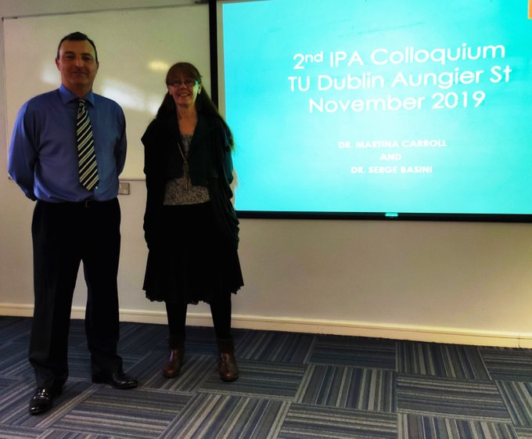

Dr Martina Carroll and Dr Serge Basini, IPA Experts in Ireland

**____________________________________________________________________________________**