How to Import Column Layout and Cell Style to Syllabus+ (SaaS)
You can import your Column Layout and Cell Style to Timetabler. Sample layouts are also available to download in the Timetabling User Group Team.
https://tudublin.sharepoint.com/:f:/r/sites/SyllabusTimetablingUserGroup/Shared%20Documents/General/Layouts?csf=1&web=1&e=rRRVid
Download and save the files to your desktop.
IMPORT COLUMN LAYOUT
- To import your files, click on the drop down arrow at the top of your webpage.

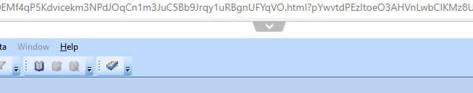

- Click on ‘From PC to Server’
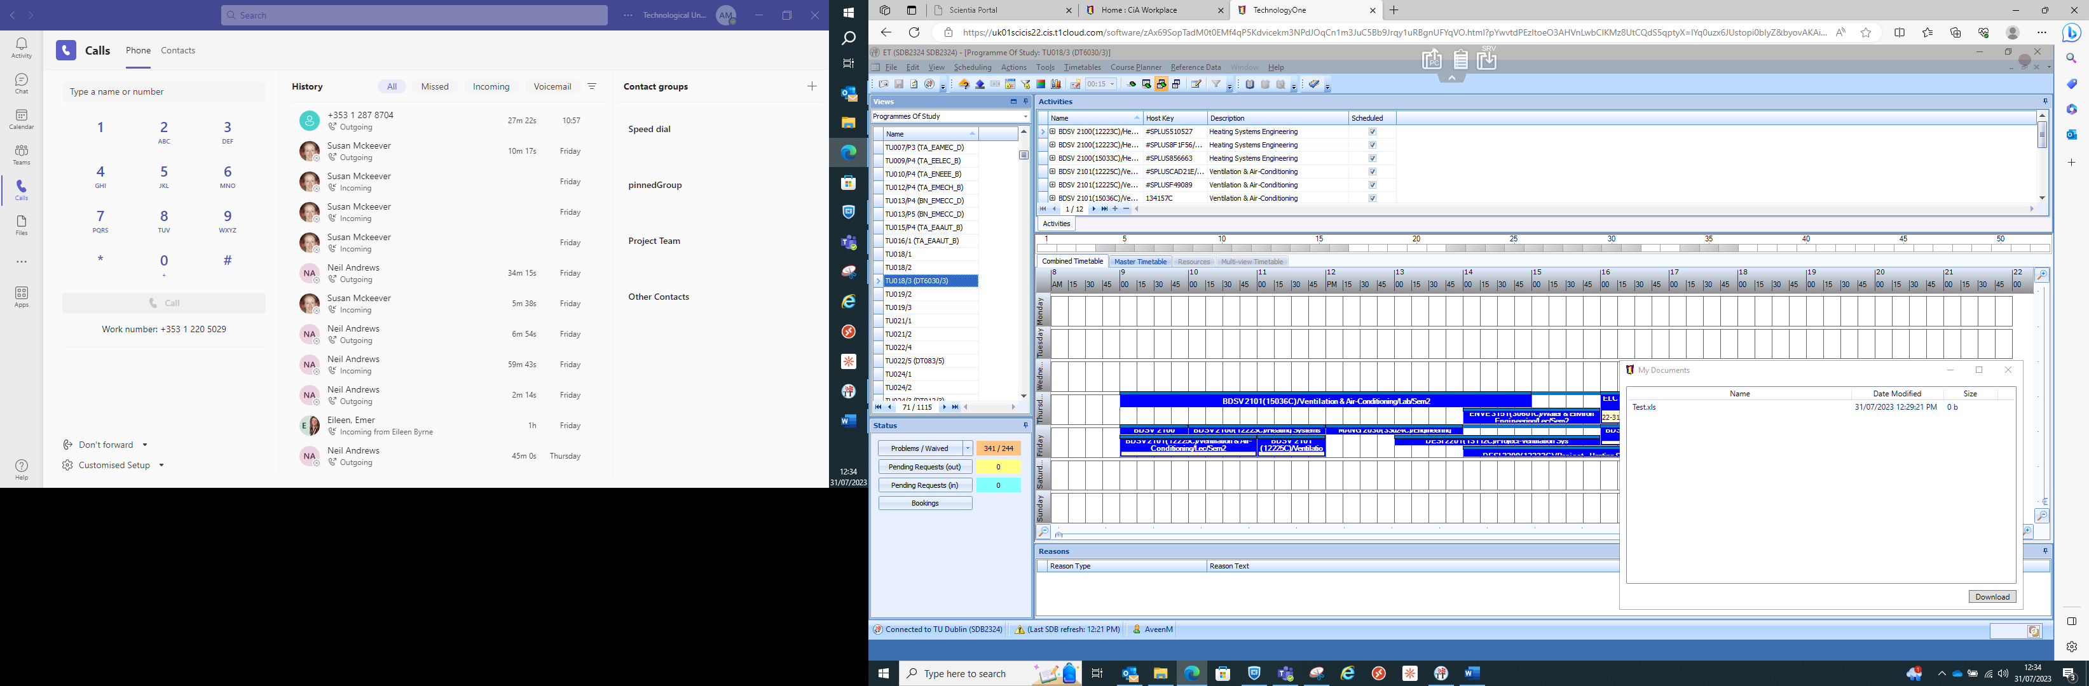

- Click on ‘Click here to select your file!’
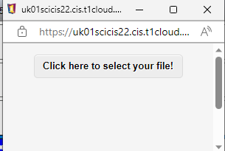

- Navigate to your saved files. Select both files and click on ‘Open’
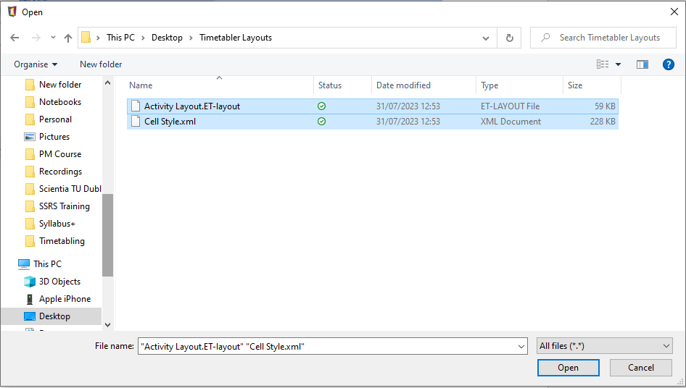

- Right click on name in the activity view and then ‘Load Layouts from Disk’
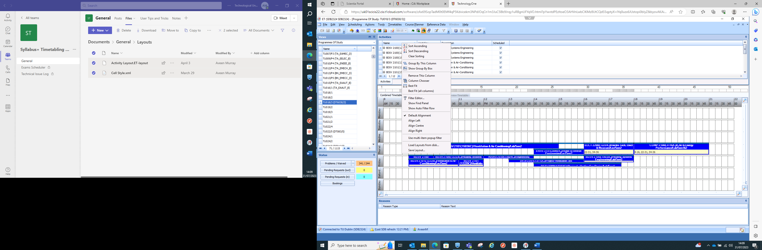

- Select the file and click on ‘Open’
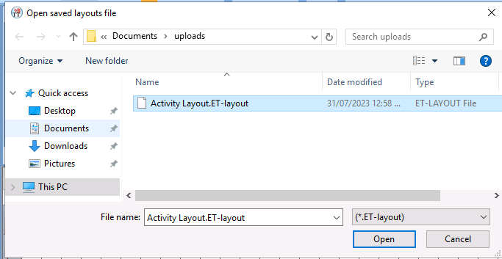

- Right click on name in the activity view and then ‘Restore Layout’ and Select Activity List
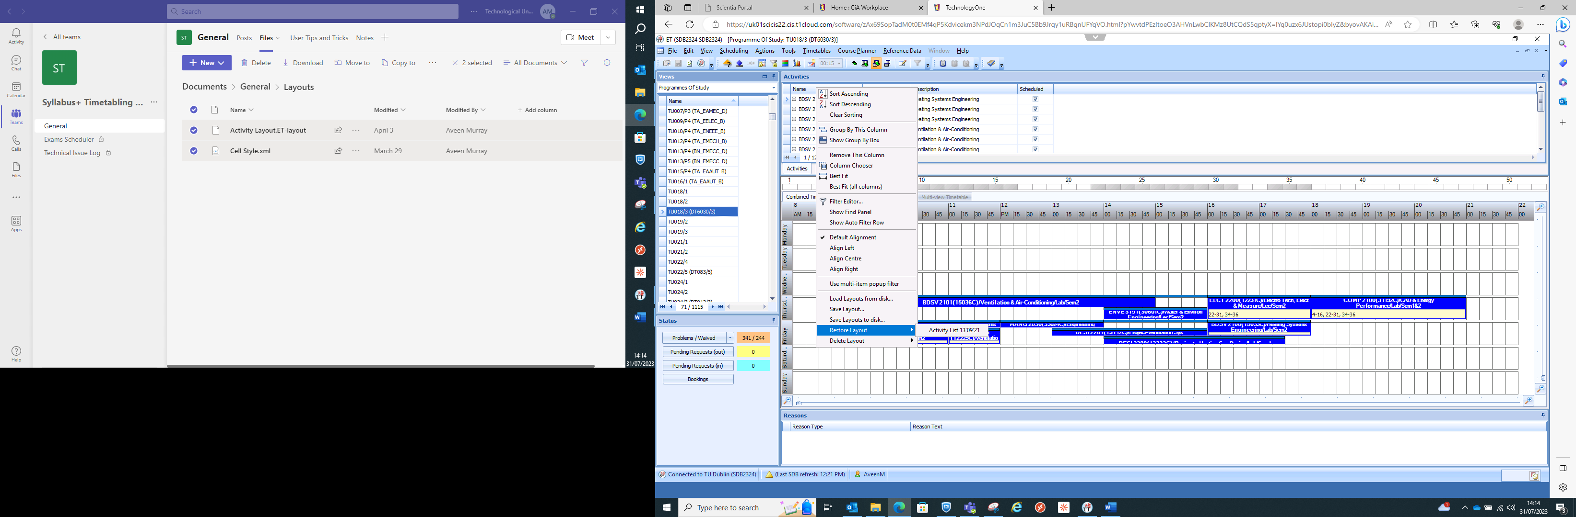
IMPORT CELL STYLE
- Click on the ‘Activity Layout’ icon.
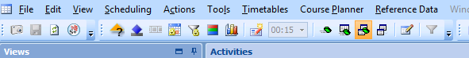

- Click on the ‘Load’ icon
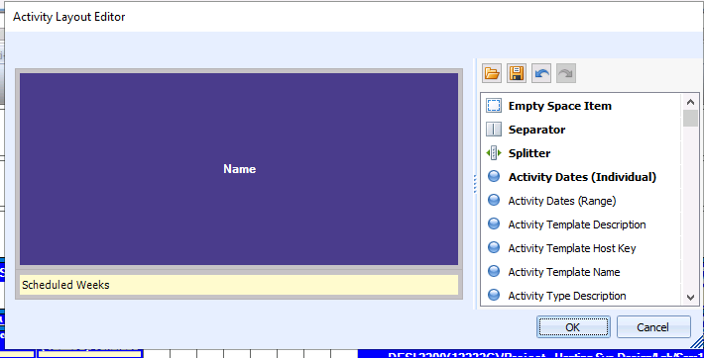

- Highlight the file and click on ‘Open’
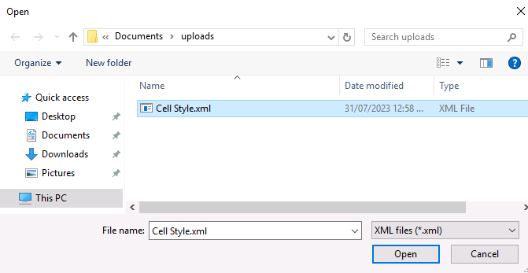

- Click on ‘OK’
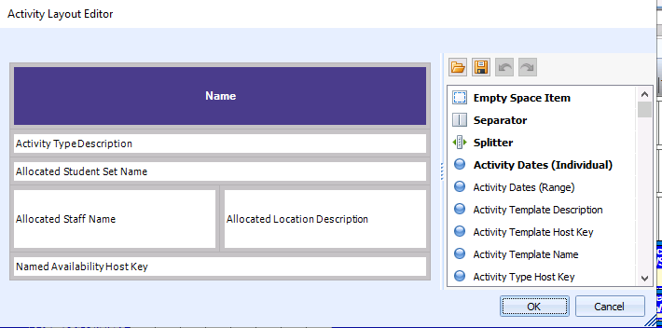

You can edit either layout to suit you. Timetabler will save both layouts.

