**How to Export Data from Syllabus+ (SaaS)**

Data held in Syllabus+ can be exported to various file types including PDF, Excel and CSV.. All data available in the activity viewer can be filtered and exported.

In the below example, we will export all activities in CQ-104 to an excel file.

1. Click on the location in the location view to populate the Activity List (filters can be applied to the list view)

1. Click on File – Print – Activity Viewer. This will open a preview of the data in a separate screen.

1. Click on File – Export Data and then the relevant file type.

1. Click Ok in next dialogue box.

1. This will open the Save As dialogue box. Select This PC →Documents to save the file and then name it. ***(The document has been saved to the Remote SaaS Desktop not your own PC/Laptop)***

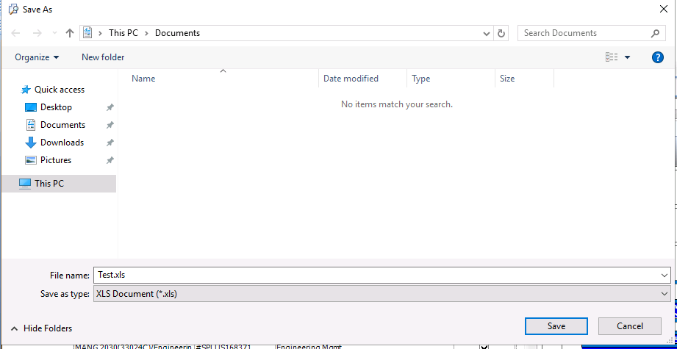

1. To access your file, click on the drop down arrow at the top of your webpage.

1. Click on ‘From Server to PC’

1. This will open a dialogue box. Highlight the document and click on Download. This will open the document and you can now save this document to your own PC/Laptop.

**Downloads will only stay in your folder for your session, so you please ensure that you download them before logging out.**