How To Access Syllabus+ Enterprise Timetabler
Syllabus+ url: https://tudublin.t1cloud.com/
- Open the url and Click on All Roles
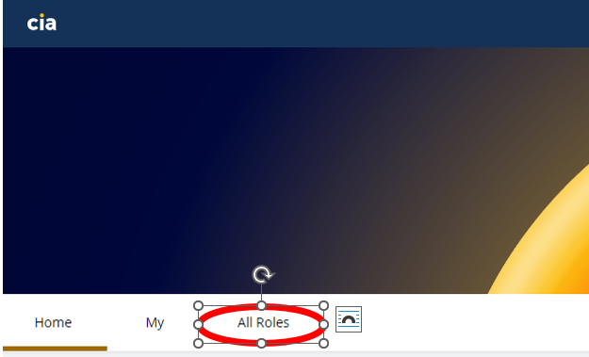

- Scroll down to Timetabling and Scheduling. Click on the Pin on the SyllabusPlus Anywhere Tile.
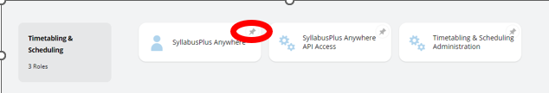

- You should now see SyllabusPlus Anywhere on your Dashboard. Click on the down arrow to show the Databases you can access.
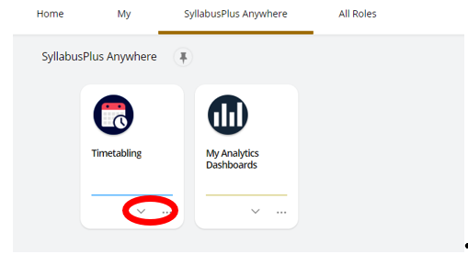

- Click on the relevant database to open
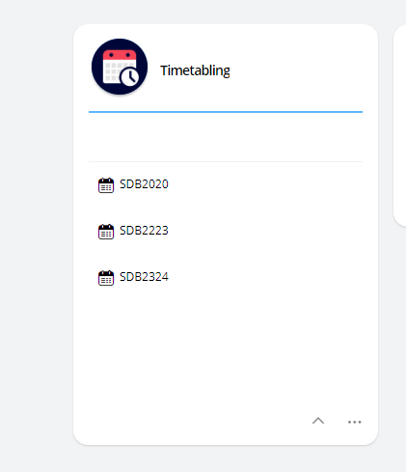

- Click on Install. Enterprise Timetabler will now open as usual.
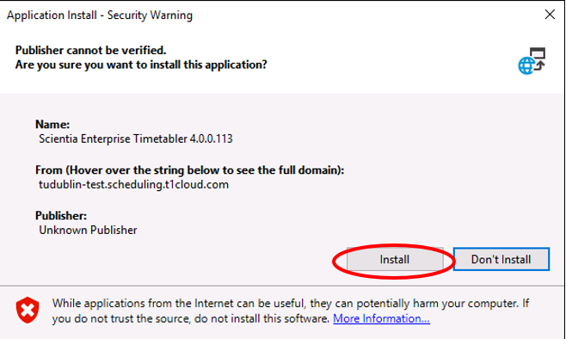

Once you have Timetabler open, the dataset will appear as normal in the top left hand corner.
Both Course Planner and Reference Data Manager can be accessed directly from Timetabler

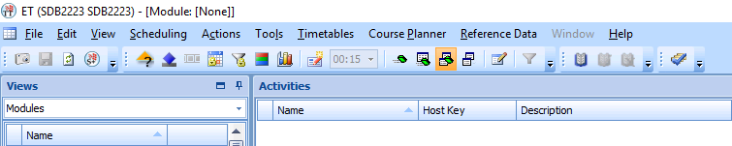
Always Exit from S+ by using File - Exit

