**GZAREPS – Run Oracle Reports in Banner 9**

The following are screenshots of the reports available from GZAREPS.

The most popular reports to run are

SZRCLAL Class list

SZRDCSI Class list by CRN

SZRSCNT Registered student count

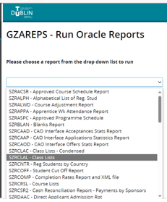 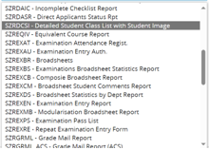

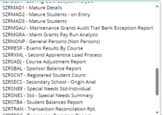 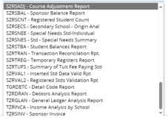

For the Registrars department, they admissions and exams office require excel versions of banner reports. In Blanchardstown, key staff used ***Discoverer reports*** which were developed by Sandra McCullagh, the Blanchardstown Management information systems expert.

The ***discoverer*** tool is now at end of life, so it is not possible to assign new discoverer accounts. Going forward, TU Dublin will develop reports using the **Argos** reporting tool, but due to resourcing constraints, reporting developments may be for the new unified Banner from September 2025. In the interim, the following banner reports are available to colleagues with WebDAV access:

SZRCLDF Registered student class list in excel

SZRSCNT Registered student county in excel

SZREXBF Module statistical report