**Blanchardstown**

<https://ssb-bn.tudublin.ie/StudentSelfService/ssb/classListApp/classListPage#!/allTerms/courseList>

**Tallaght**

<https://ssb-ta.tudublin.ie/StudentSelfService/ssb/classListApp/classListPage#!/allTerms/courseList>

**This link should bring you into a page that looks like following:**

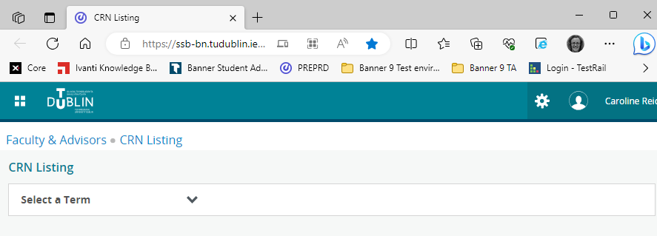

**Select academic year and a whole screen of modules appears.**

**Use the search box to select you CRN *(type the crn).***

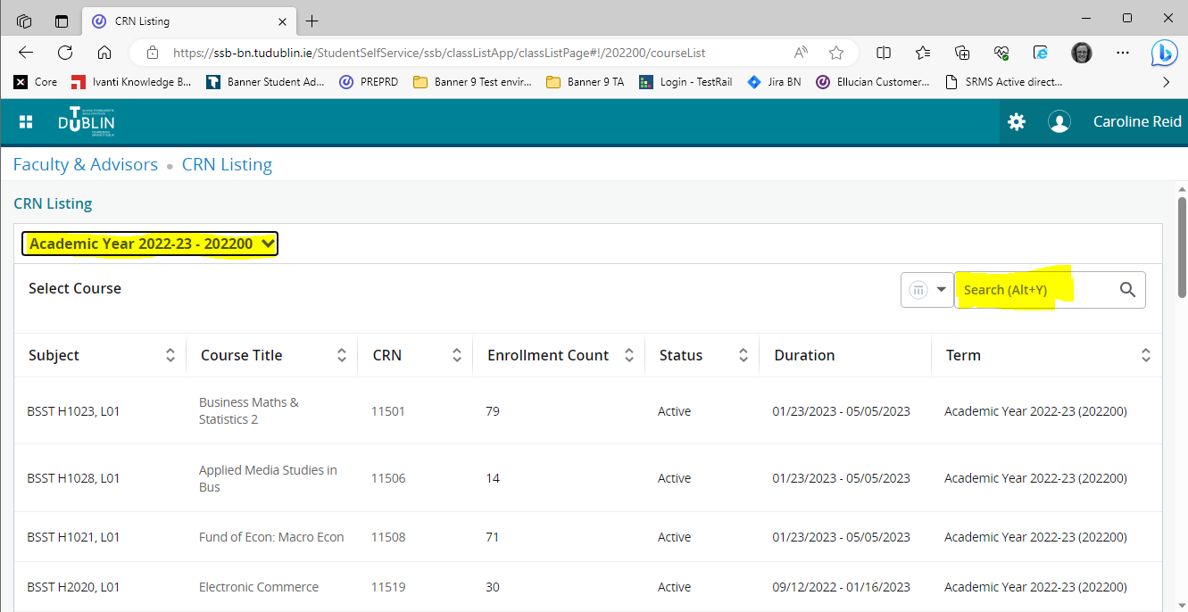

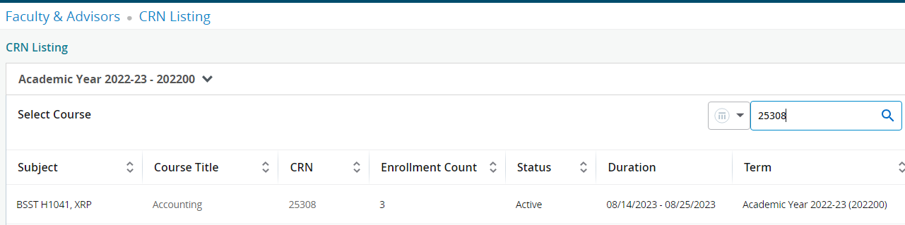

**Double click on the subject *(Module code BSST H1041 above)* and the class list of students registered on the CRN will appear.**

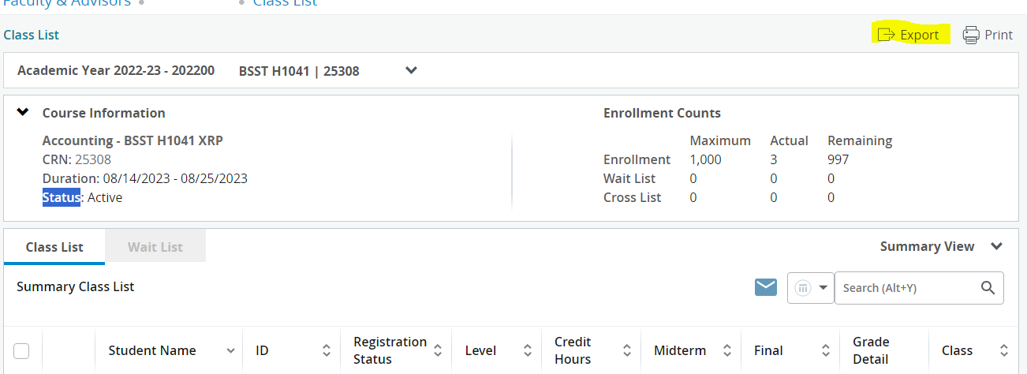

**Select Export**

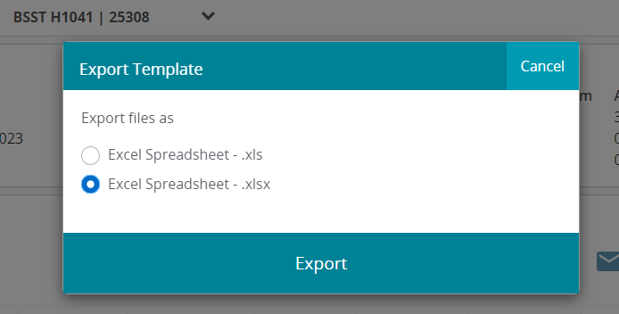

**Your export will display in the corner of your screen, select open file**

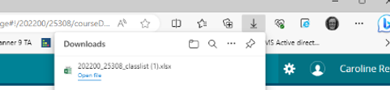

**You classlist extract will show up.**

