Safety, Health and Welfare Policy 2025

Technological University Dublin (TU Dublin) is committed to working in accordance with the provisions of the Safety, Health and Welfare at Work Act 2005, other associated legislation and the requirements of the University Safety Statement, to ensure in so far as is reasonably practicable, the safety health and welfare of its employees.

TU Dublin details in the University Safety Statement and associated safety documentation how it will ensure the safety, health and welfare of its employees and specifies the means provided to achieve this policy.

In addition, to the University commits to meeting its responsibilities under the Act to ensure students and other persons at the place of work but not in our employment, who may be affected by the work activities, are not exposed to risks, injury or ill health.

As per the General Duties of the Employer under Section 8 of the 2005 Act, TU Dublin will ensure the following absolute duties are adhered to:

- A written safety statement is maintained and updated. Hazard identification and risk assessments are carried out and control measures are implemented as far as reasonably practicable taking account of the Principles of Prevention (Schedule 3, 2005 Act). These are reviewed as required and brought to the attention of all employees and relevant persons at least annually;
- Emergency plans and procedures are prepared, tested and revised to deal with emergencies or the presence of serious or imminent danger;
- Welfare facilities are provided and maintained; and
- Accidents and dangerous occurrences are reported as required to the Health and Safety Authority (HSA).

As per the General Duties of the Employer under Section 8 of the 2005 Act, TU Dublin will ensure in so far as is reasonably practicable, that;

- Work activities are managed and conducted to ensure the safety, health and welfare of employees;
- Identified protective and preventive measures are implemented and maintained to ensure a safe learning and working environment;
- Improper conduct or behaviour likely to put an employee’s safety and health at risk is prevented;
- A safe place of work is designed, provided and maintained;
- A safe means of access and egress is designed, provided and maintained;
- Safe plant and equipment are designed, provided and maintained;
- Safe systems of work are planned, organised, performed, maintained and revised as appropriate;
- Risks to health from the use of any article or substance and from exposure to physical agents, noise and vibration, ionising or other radiations or any other physical agent are prevented;
- The necessary information, instruction, training and supervision is provided to enable staff to perform their work safely and effectively;
- A culture of safety is developed and cultivated in the University;
- Staff are engaged and consulted in relation to safety, health and welfare matters;
- Staff, students and others are aware of their obligations to comply with the safety, health and welfare rules and procedures and to report any accidents or dangerous occurrences immediately;
- Policies to protect the safety, health and welfare of staff including vulnerable staff with disabilities, issues relating to maternity, young persons will be developed;
- Where risks cannot be eliminated or adequately controlled, or in such circumstances as may be prescribed, suitable protective clothing and equipment is provided and maintained; and
- The services of competent personnel are obtained where necessary for the purpose of ensuring the safety, health and welfare of employees and students.

TU Dublin will allocate the necessary resources (land, infrastructure, buildings, financial, equipment, staff and time) and structures to safeguard employees, students and all other campus users against the risks arising from activities in the workplace as far as is reasonably practicable.
The implementation of the TU Dublin Safety, Health and Welfare Policy depends on the co-operation of staff, students and others. It is the duty of everyone affected by TU Dublin’s activities to understand and comply with the safety, health and welfare policy, protocols and procedures in place at the campus on which they work/study. Each employee is expected to make themselves familiar with the contents of the Safety Statement. In addition, employees and students must also make themselves familiar with their School/Function risk assessments, safety documentation and local safety arrangements. Employees with specific responsibilities for safety, health and welfare must properly delegate these in their absence.

Systems are developed and maintained for effective communication of safety, health and welfare information and employees will be consulted on matters relating to safety, health and welfare at work. Employees and others are encouraged to put forward suggestions for improvement to the University Safety Statement.

The safety, health and welfare policy will be reviewed annually.

Signed:

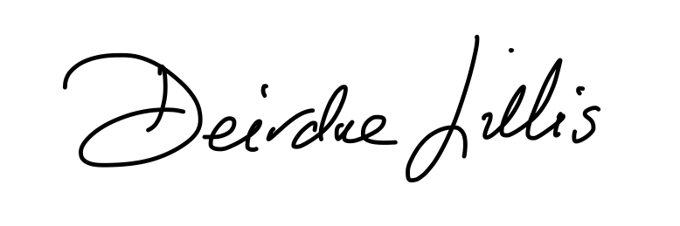
President, Technological University Dublin Date: 18th February 2025

