**TRINITY HALL ACCOMMODATION RATHMINES**

SPECIAL ROOM-ONLY RATE TU DUBLIN STUDENTS

* **ENSUITE SINGLE ROOM €55 ROOM ONLY**

TO BOOK follow the instructions below:

<https://www.visittrinity.ie/stay/book-dartry/>

* Book now
* Select code **TUD511** and apply code **screenshot 1**
* Enter date range, and apply dates (must be between **8-15 June** to avail of promo code rate) **screen shot 2**
* Rates are room only, per night.
* Full payment is taken at the time of booking. A full refund will be provided once cancelled 72 hours in advance of the arrival date.
* Limited availability available.
* Any questions please email [**reservations@tcd.ie**](mailto:reservations@tcd.ie)

1.

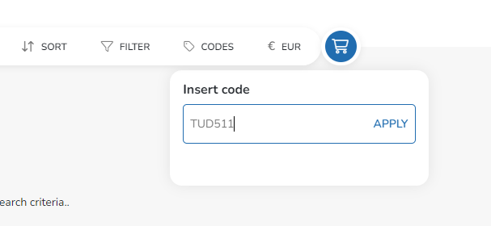

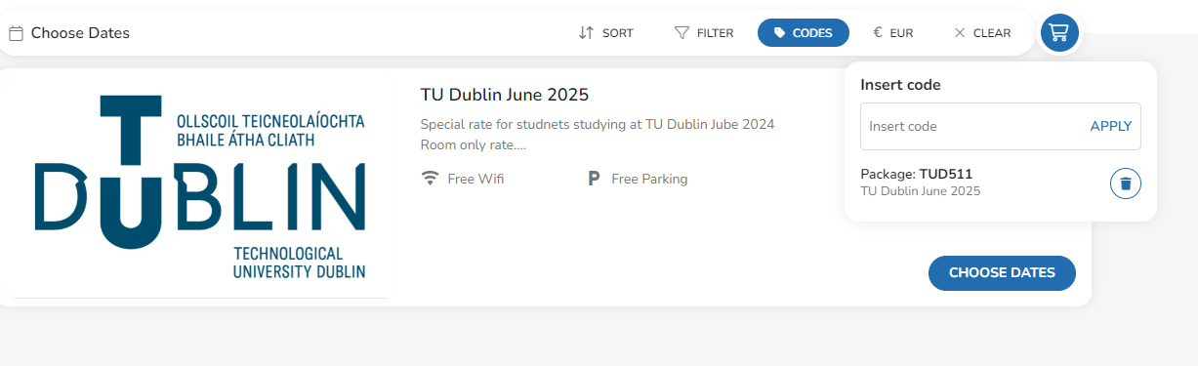

**2.**

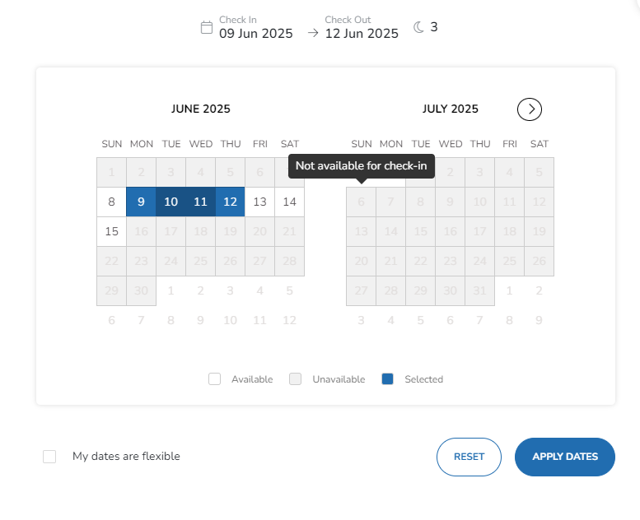

3.

