How to Create an Autodesk Educational Account
- Go to https://www.autodesk.com/education/edu-software/overview
- Click on the “Get Started ->” button
- Click on “CREATE ACCOUNT”
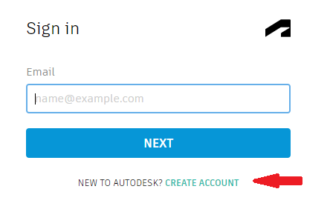
- Choose “Ireland” in the Country box, “Student” in Educational role, and “University” in the Institution Type box and then your date of birth, click next.
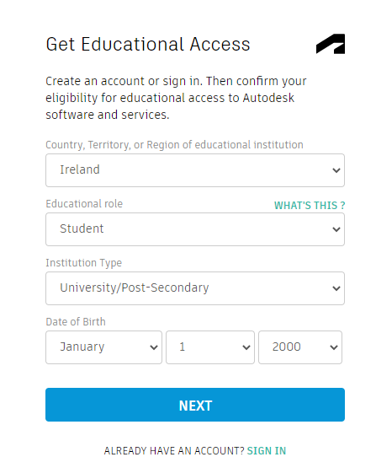
- Enter your name, TU Dublin email address and a password for your Autodesk Account and tick the box, if you agree with the Autodesk Terms of Use.
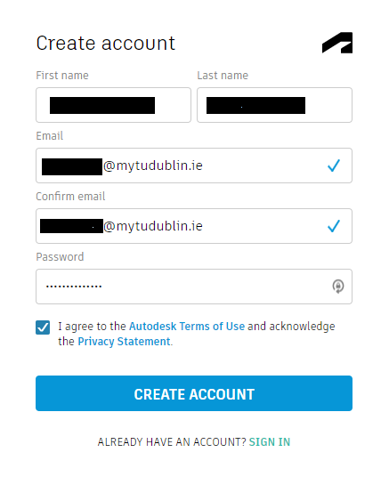
- An email will be sent to verify your email address, log into your email, and click on the link in the email.

- Once verified you should be redirected to the login screen, if not just click on the link above, click on get started.

- Sign in using your TU Dublin email address and click next, enter your password, and sign in.

- Enter “Tudublin (Dublin)” into the Name of educational institution box, fill out the remaining boxes as appropriate and click next.
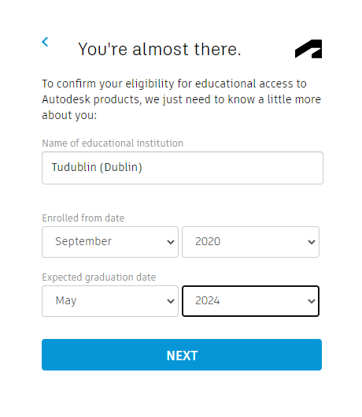

- On the next screen, confirm that the information is correct and click confirm.
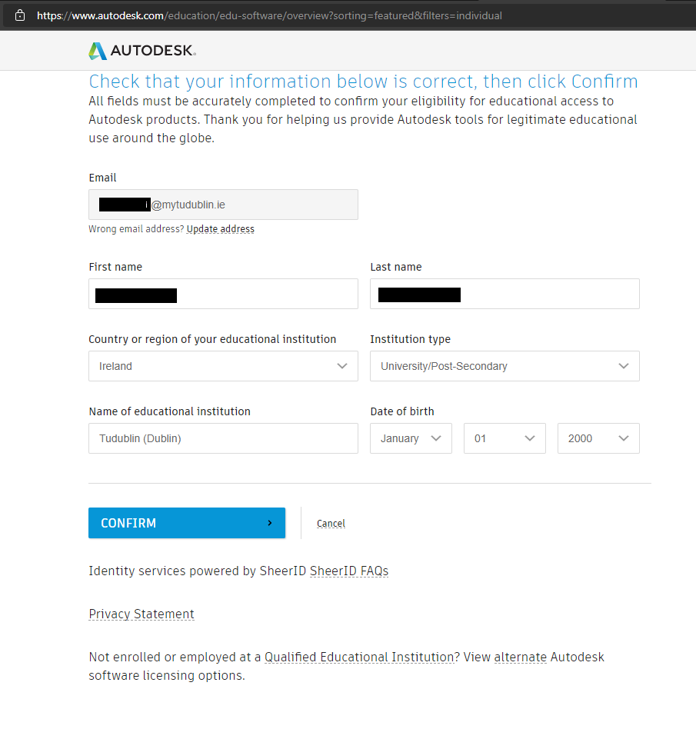
- Click on the “Confirm Eligibility…” button
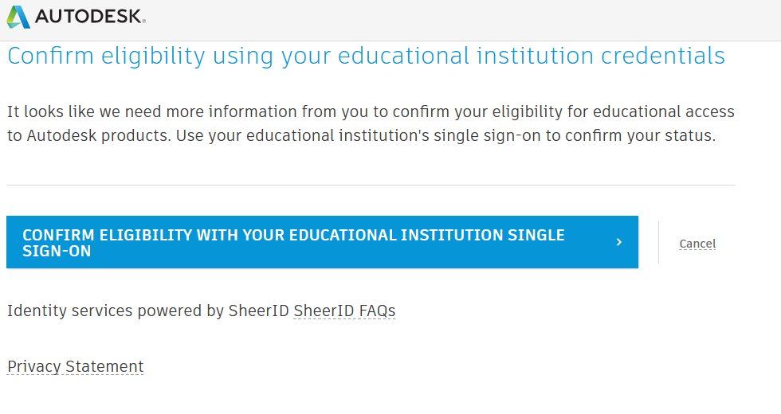

- Enter your TU Dublin email address and click next, enter your password click Sign in, you maybe asked to enter a multifactor code
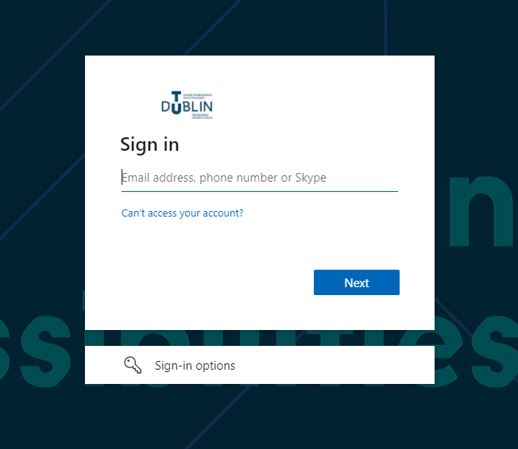
- You should now be confirmed and have an Autodesk Account, click on the link above and download the required applications. Once the applications are installed, open the application and login with your Autodesk Account to licence the application.

- If Autodesk does not offer you the single sign on option above (#10 & #11 above) but instead requires that you provide a document to verify that you are attending TU Dublin, please fill out this form and a letter will be emailed to you. Letters will only be issued to registered students.

Student Form:
http://bit.ly/student_autodesk_tudublin
Or
Staff Form:
http://bit.ly/staff_autodesk_tudublin

