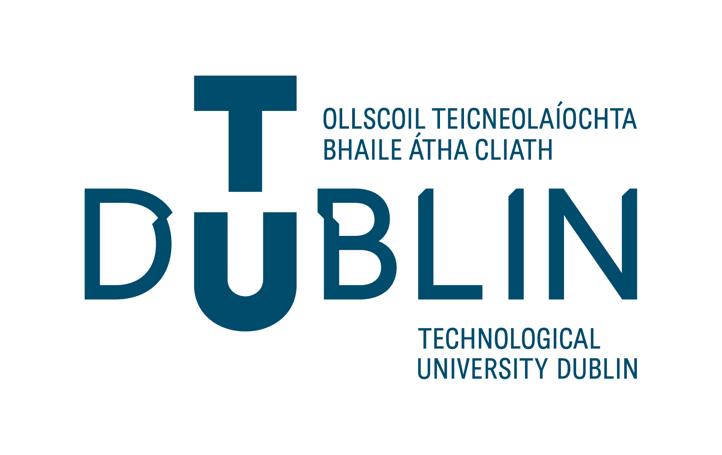

Application Form for Visiting Scholar (Academic/Researcher) in TU Dublin
This application form should be completed by the applicant and sent to the relevant Academic Unit/Research Hub/Centre for approval.
1. Applicant Details Title
Name and details of the proposed candidate for Visiting Scholar
Title
First Name
Surname
Date of Birth
Home Address
Educational Qualifications
Current Employment – Position/Title
Current Employer/University
Current Telephone
Current Email Address

Please attached full up-to-date Curriculum Vitae.

2. Visit Proposal
Details of own medical insurance
Permission to work in Ireland (if required)
Please outline the intended work to be carried out during your visit at TU Dublin

Declaration
I declare that the information given by me in this form is true and accurate at the best of my knowledge and that, if I am admitted as a visiting scholar, I will abide by all the regulations and policies of the TU Dublin.

Signature ________________________
Applicant’s Signature

Name: ________________________

Date: ________________________

PART B
Approval Form

The Dean / Vice President [delete as appropriate] has assessed this application and agrees that:

- The candidate will make a significant and distinguished contribution to teaching, research and professional activities at TU Dublin;

- The proposed activities are appropriate to be carried out in the relevant academic unit/Research Centre or Hub which will host the candidate;

- The relevant academic unit /Research Centre or Hub can provide the facilities and resources required for the proposed candidate.

- __________________ has been appointed as mentor of this visiting scholar who will visit TU Dublin City from: ____________ to:______________.
- Visiting scholar will be based in ______________.

Signature : ________________________________ Date: _________________________
Approver’s Signature

Name: ________________________

Position: ______________________

Appendix 1
Visiting Researcher Intellectual Property Agreement
All Visiting Researchers are required to sign the attached agreement and lodge it with the TU Dublin Technology Transfer Office before the visit commences.
1. Confidentiality
In the performance of his/her duties the Visiting Researcher (hereafter called VR) is likely to come into possession of Confidential Information which may be confidential to TU Dublin (hereafter TU Dublin), its staff, students, sponsors or clients. The VR will keep all such Confidential Information secret and will also refrain from using it for personal gain or for any purpose not associated with his/her activities as a VR, and from divulging any such Confidential Information to a third party. This prohibition will have effect for the duration of the visit, and for the three years following its termination/expiry.
All Confidential Information and all other documents, papers and property of TU Dublin and all copies thereof shall, upon request, be either (at TU Dublin’s option) returned to TU Dublin or destroyed.
Confidential Information includes any and all information in oral, written, graphic, machine recognisable or sample form which is clearly designated, labelled or marked as confidential, or which TU Dublin or other disclosing party regards or could reasonably be expected to regard as confidential or which is obtained by examination, testing or analysis of any data, material, hardware, software or component part. Confidential Information includes any information relating to or comprising any Foreground Intellectual Property Rights which TU Dublin regards, or could reasonably be expected to regard, as confidential, whether or not designated, labelled or marked as such.
2. Intellectual Property
(a) Background Intellectual Property
Each party shall retain ownership of all his/her/its right, title and interest in his/her/its background knowledge (whether patented or not) and intellectual property rights in existence, whether declared or not, prior to entering into this Agreement.
The VR grants to TU Dublin a non‐exclusive, royalty‐free, perpetual licence (with the right to grant sub‐licenses) to use his/her background knowledge and intellectual property rights in the development of any research project that may arise from this visit and otherwise to the extent necessary to exploit any Foreground Intellectual Property. The VR warrants to TU Dublin that he/she owns all such background knowledge and intellectual property rights and further is entitled to license the same on the foregoing terms.
(b) Foreground Intellectual Property
All intellectual property rights (including patents, designs, copyrights, inventions, technical information, know‐how and similar rights, and rights to apply for any of the foregoing) produced, invented or discovered by the VR (alone or in conjunction with others) in the course of his/her duties or other activities undertaken by him/her on behalf of TU Dublin (“Foreground Intellectual Property”) shall belong to and vest in TU Dublin and, to the extent that such rights do not vest in TU Dublin either by operation of law or by virtue of the foregoing, the VR shall hold such rights in trust for TU Dublin.
The VR assigns and agrees to assign all his/her right, title and interest in and to such Foreground Intellectual Property Rights to TU Dublin.
The VR also agrees to do all acts (including the execution of all appropriate documents and instruments) which TU Dublin, at its cost and in its absolute discretion, considers necessary or desirable for the purpose of giving full force and effect to the foregoing. As security for his/her obligations under this Section 2, the VR irrevocably appoints TU Dublin as his/her attorney in his/her name and on his/her behalf to execute such instruments and /or documents and generally to use his/her name for the purpose of doing all such acts as may be required of the VR from time to time under this Section 2.
Where TU Dublin decides not to protect/exploit an invention, discovery, device, product, method or technology developed or contributed to by the VR, TU Dublin may assign its rights to the relevant inventor(s), who may then develop the commercial application of the invention, discovery, device, product, method or technology as s/he sees fit from his/her own resources.
(c) Distribution of IP Benefits
Where the VR is recognized as an inventor in any invention patented by TU Dublin and subsequently commercially exploited by TU Dublin, the VR will be entitled to share in any income derived from such exploitation in accord with the terms of the TU Dublin Policy on Intellectual Property (such as it may be in force from time to time).
The provisions of this Section 2 shall survive the termination or expiry of the visit.
3. Publications
It is TU Dublin’s policy to encourage staff, students and anybody connected with TU Dublin to discuss, and publish the results of research as soon, and as fully, as may be reasonable and possible. However, premature publication of the details of an invention or other know‐how may make it impossible to seek later patent protection, and accordingly, all proposed publications must be approved in advance in writing by TU Dublin’s Technology Transfer Office.
Publication in this sense means putting the public in possession of information relating to an invention or other know‐how by way of speech, talk, paper, drawing, photograph, printed work, tape, video‐recording, internet or other electronic means, or any other disclosure given or distributed, except on a confidential basis.
Acceptance of the Visiting Researcher:
I (print)_____________________ agree to accept the visit to TU Dublin on the Terms and Conditions set out above.
Signed, Sealed and Delivered
by the Visiting Researcher (VR):__________________________________(signature)

Witness:______________________________
Name: ________________________Date: _________________________
This form should be forwarded to the office of Head of Research Support Services at research@tudublin.ie.

